SquadUp – Player Matching Platform
A Cornerstone Project Report submitted in partial fulfillment of the requirements for the award of degree of
BACHELOR OF TECHNOLOGY
in
ARTIFICIAL INTELLIGENCE AND MACHINE LEARNING
Submitted
by
Chikkala Sri Naga Vijay Kumar (24B11AI062)
Devarakonda Sri Sashank (24B11AI085)
Guvvala Sai Sri Pavan (24B11AI139)
Mohammed Akmal Kanna Mangalam (24B11AI262)
Under the Guidance of
Mrs. Khasimbee Shaik, M. Tech (Ph.D)
Assistant Professor, AIML

DEPARTMENT OF ARTIFICIAL INTELLIGENCE AND MACHINE LEARNING
ADITYA UNIVERSITY
2024-2028

School of Computing
Department of Artificial Intelligence and Machine Learning
CERTIFICATE
This is to certify that the project work entitled “SquadUp – Player Matching Platform” is submitted by
Chikkala Sri Naga Vijay Kumar (24B11AI062)
Devarakonda Sri Sashank (24B11AI085)
Guvvala Sai Sri Pavan (24B11AI139)
Mohammed Akmal Kanna Mangalam (24B11AI262)
in partial fulfilment of the requirements for the award of the B.Tech degree in Artificial Intelligence and Machine Learning for the academic year 2026-2027.
Project Guide | Head of the Department
Mrs. Khasimbee Shaik, M.Tech (Ph.D). | Dr. K. Naga Bhargavi M.Tech, Ph.D.
Assistant Professor, AIML | Associate Professor & HOD, AIML
External Examiner

DECLARATION
We hereby declare that the project entitled “SquadUp – Player Matching Platform” is original and is submitted to ADITYA UNIVERSITY, Surampalem in partial fulfilment of the requirements for the award of the B.Tech degree in Artificial Intelligence and Machine Learning. We further declare that this project work has not been submitted, either in full or in part, for the award of any degree in this or any other institution. We also confirm that this work complies with the Institutional Academic Integrity and AI Usage Policy.
Place: Surampalem
Date: 14/10/2026
by
Chikkala Sri Naga Vijay Kumar (24B11AI062)
Devarakonda Sri Sashank (24B11AI085)
Guvvala Sai Sri Pavan (24B11AI139)
Mohammed Akmal Kanna Mangalam (24B11AI262)

ACKNOWLEDGEMENT
It is with immense pleasure that we would like to express our indebted gratitude to our project guide Mrs. Khasimbee Shaik, Department of Artificial Intelligence and Machine Learning, who has guided us a lot and encouraged us in every step of the project work. Her valuable moral support and guidance throughout the project helped us to a greater extent.
We are grateful to Dr. B. Manikyala Rao (Dy.HOD), for inspiring us all the way and for arranging all the facilities and resources needed for our project.
We are grateful to Dr. K. Naga Bhargavi (HOD), for inspiring us all the way and for arranging all the facilities and resources needed for our project.
We wish to thank our Dr. M.V. Rajesh, Associate Dean (School of Computing), Dr. A. Ramesh, Pro Vice-Chancellor (Engineering & Sciences), Dr. S. Rama Sree, Pro Vice-Chancellor (Academics) and Dr. G. Suresh, Registrar, for their encouragement and support during the course of our project.
We would like to extend our sincere thanks to Dr. M. B. Srinivas, Vice-Chancellor, Dr. M. Sreenivasa Reddy, Deputy Pro-Chancellor and Management, Aditya University for their unconditional support in providing us with the best infrastructural facilities and state-of-the-art laboratories during our project.
Not to forget, Non-Teaching Staff and our Friends who have directly or indirectly supported us in completing this project on time.

ABSTRACT
SquadUp is a web-based player matching platform that gives online gamers a centralized place to find teammates who suit them socially as well as in skill. Standard matchmaking looks only at skill rating and latency, whereas SquadUp lets players create and join squads (“Looking for Group” lobbies) that are built around the game being played, the language spoken and the play style. The backend is developed using Java Spring Boot, Spring Data JPA, RESTful web services and a relational database (H2 by default and MySQL through a profile), and the frontend is developed using HTML, CSS and JavaScript served by the same application.
The system allows players to register, maintain a gaming profile, search a paginated player directory and filter squads by game, language and open slots. A scoring engine recommends squads to each player and explains every recommendation. Players can send and answer friend requests, and chat in real time in squad rooms and private rooms through WebSocket (STOMP) messaging, where banned words are masked automatically and typing indicators and friend notifications are delivered instantly.
To improve maintainability and reliability, the project demonstrates token-based Spring Security, Spring AOP logging, performance timing and auditing, Bean Validation, centralized exception handling and declarative transaction management with pessimistic locking. It also includes a contract-first SOAP web service that returns public player information. Overall, the system provides a structured and reliable approach to building squads while demonstrating important API and micro-services concepts, and it is verified by 55 automated tests.
Keywords: Player Matching, Squad Finder, Looking for Group, RESTful APIs, Spring Boot, Spring Data JPA, Spring Security, Spring AOP, WebSocket, STOMP, SOAP Web Service, Bean Validation, H2, MySQL

TABLE OF CONTENTS
Section / Chapter | Title | Page
CHAPTER 1 | INTRODUCTION | 1
1.1 | Introduction | 1
1.2 | Problem Statement | 1
1.3 | Objectives of the Project | 2
1.4 | Scope of the Project | 2
CHAPTER 2 | SYSTEM OVERVIEW | 4
2.1 | System Architecture | 4
2.2 | System Flow | 5
2.3 | User Roles | 6
2.4 | System Modules | 6
CHAPTER 3 | TECHNOLOGIES USED | 7
3.1 | Java | 7
3.2 | Spring Boot | 7
3.3 | HTML, CSS and JavaScript | 7
3.4 | RESTful Web Services | 7
3.5 | Spring Data JPA | 8
3.6 | H2 and MySQL | 8
3.7 | Spring Security | 8
3.8 | Spring AOP | 8
3.9 | Validation and Exception Handling | 9
3.10 | SOAP Web Service | 9
3.11 | WebSocket and STOMP | 9
3.12 | Maven and VS Code | 9
CHAPTER 4 | DATABASE DESIGN | 10
4.1 | Database Tables Overview | 10
4.2 | Users Table | 10
4.3 | User Game Tags and Platforms Tables | 11
4.4 | Squads Table | 11
4.5 | Squad Members Table | 11
4.6 | Friendships Table | 11
4.7 | Messages Table | 12
4.8 | Auth Tokens Table | 12
4.9 | Database Relationships | 12
CHAPTER 5 | SYSTEM MODULES | 13
5.1 | Authentication and Player Profile | 13
5.2 | Squad Management | 13
5.3 | Squad Recommendation Engine | 13
5.4 | Friends Management | 14
5.5 | Real-Time Chat | 14
5.6 | Platform Statistics | 14
5.7 | SOAP Player Service | 14
5.8 | Logging, Audit and Error Handling | 15
CHAPTER 6 | API AND IMPLEMENTATION | 16
6.1 | Frontend Implementation | 16
6.2 | Backend Implementation | 16
6.3 | REST API Operations | 17
6.4 | Transaction Management | 18
6.5 | Spring AOP Logging | 18
6.6 | Validation and Exception Handling | 19
6.7 | Real-Time Communication with WebSocket | 19
6.8 | SOAP Player Service | 20
6.9 | API Versioning, CORS and REST Client | 20
6.10 | Testing | 20
CHAPTER 7 | OUTPUT SCREENS | 22
7.1 | Login Screen | 22
7.2 | Player Profile | 22
7.3 | Filtered Squad Lobby | 23
7.4 | Recommended Squads | 24
7.5 | Friends List | 24
7.6 | Pending Friend Requests | 25
7.7 | Real-Time Friend Notifications | 25
7.8 | Squad Chat and Message Moderation | 26
7.9 | Typing Indicator | 27
7.10 | Paged Player Search | 27
7.11 | Filtering with Matrix Variables | 28
7.12 | Login API and Token Response | 29
7.13 | Secured API Error Responses | 29
7.14 | SOAP Player Service | 30
7.15 | Platform Statistics | 31
7.16 | Audit and Performance Logs | 32
7.17 | Seeded Database | 32
7.18 | Automated Test Result | 32
CHAPTER 8 | CONCLUSION | 34
8.1 | Summary | 34
8.2 | Future Enhancements | 35
 | REFERENCES | 37

LIST OF FIGURES
Figure | Description | Page
Figure 2.1 | System Architecture | 4
Figure 4.1 | Database Design | 10
Figure 6.1 | Project Structure | 16
Figure 7.1 | Login Screen | 22
Figure 7.2 | Player Profile | 23
Figure 7.3 | Filtered Squad Lobby | 23
Figure 7.4 | Recommended Squads with Score and Reasons | 24
Figure 7.5 | Friends List | 25
Figure 7.6 | Pending Friend Requests | 25
Figure 7.7 | Request Received in Real Time | 26
Figure 7.8 | Request Accepted in Real Time | 26
Figure 7.9 | Squad Chat with a Censored Message | 27
Figure 7.10 | Typing Indicator | 27
Figure 7.11 | Paged Player Directory | 28
Figure 7.12 | Matrix Variable Request and Response | 28
Figure 7.13 | Login Response with Bearer Token | 29
Figure 7.14 | 401 Unauthorized Response | 29
Figure 7.15 | 403 Forbidden Response | 30
Figure 7.16 | WSDL of the SOAP Service | 30
Figure 7.17 | SOAP Request and Response | 31
Figure 7.18 | Platform Statistics | 31
Figure 7.19 | Audit and Performance Logs | 32
Figure 7.20 | Seeded Players in the H2 Console | 32
Figure 7.21 | Maven Test Result | 33

CHAPTER 1

INTRODUCTION

1.1 Introduction
SquadUp is a player matching platform developed for the API and Micro Services course. It is built on the requirements of the course, which include Spring basics and dependency injection, Spring Boot, Spring Data JPA, RESTful web services, SOAP web services, validation, exception handling and AOP-based logging. The project was originally built on the MERN stack (MongoDB, Express, Node.js and Socket.io); in this work the whole backend has been replaced by a Spring Boot application so that every unit of the syllabus is used in real application code.
Standard matchmaking in multiplayer games considers the skill and the latency of a player, but the things that actually make a team work, such as the language the players speak and the way they like to play, are ignored. In SquadUp every player maintains a profile containing the favourite game, skill level, platforms, play style, language and region. Players create squads, which are open lobbies with a game, a language and a maximum size, and other players join them. The backend compares the profile of the player with the open squads and returns a ranked list of recommended squads, each with the reasons for which it was selected.
The application provides one web experience for players and additional interfaces for other clients. Players browse and filter squads, manage friends and chat in real time through a browser. All operations are exposed through a Spring Boot backend as RESTful web services, real-time messages travel over WebSocket with the STOMP protocol, and a SOAP service allows external systems to look up public player information.

1.2 Problem Statement
- Standard matchmaking considers skill rating and latency but ignores language, play style and personal compatibility, so teams often fail to communicate or cooperate.
- Players who look for teammates depend on scattered channels such as social media groups and chat servers, where it is difficult to see how many slots are open or whether a group suits them.
- Public squad lists are the same for everyone, so a player has to read through every lobby to find one that plays their game in their language.
- Teams need real-time communication to coordinate, but open chats are often toxic and unmoderated.
- When several players act at the same time, for example by joining the last open slot of a squad, the data must stay consistent and the squad must never be overfilled.
- Account data and private chats must be protected so that each player can access only their own information, and external systems need a safe way to read public profiles without e-mail addresses being exposed.

1.3 Objectives of the Project
- Provide a centralized platform where players can register, build a gaming profile and find teammates.
- Allow players to create squads with a name, a game, a language and a maximum size, and let other players join or leave them.
- Search and filter squads by text, game, language and open slots with pagination and sorting.
- Recommend squads to each player using deterministic, explainable scoring rules and display the reasons for every recommendation.
- Allow players to send, accept, reject and remove friend requests and see the changes instantly.
- Provide real-time chat in squad rooms and private rooms with typing indicators and automatic masking of banned words.
- Protect the API with token-based authentication, BCrypt password hashing and ownership checks.
- Improve reliability through validation, declarative transactions, pessimistic locking, AOP logging and centralized exception handling.
- Demonstrate RESTful, SOAP-based and WebSocket-based integration within the same application.
- Verify the behaviour of every unit of the syllabus with automated tests.

1.4 Scope of the Project
The scope of the project covers user registration and authentication, player profile management, squad creation, search, filtering, joining and leaving, rule-based squad recommendation, friend management, real-time chat and notifications, platform statistics, a SOAP player service, validation, logging and auditing, and data persistence in an H2 or MySQL database.
The recommendations shown by the system are based entirely on the information entered by the players and are intended to support their decision; they are not a guarantee of compatibility. Measurement of in-game skill or latency, voice and video chat, integration with the APIs of game publishers and a native mobile application are outside the scope of the present work. The Events page of the web interface is a front-end showcase of upcoming tournaments and is not yet backed by the API.
CHAPTER 2

SYSTEM OVERVIEW

2.1 System Architecture
The system follows a layered, centralized application architecture. The web pages are written in HTML, CSS and JavaScript and are served by the same Spring Boot application. The pages call the backend through RESTful web services in JSON format and attach the bearer token received at login to every request. Every request first passes through the Spring Security filter chain, which authenticates the token and rejects unauthenticated access to the API.
The controller layer receives the request and passes it to the service layer, where the business rules, squad matching, chat moderation and transaction management are implemented. Spring Data JPA is used for persistence, and a relational database stores the player, squad, friendship, message and token information. Spring JDBC is used for the statistics query. A SOAP endpoint and a WebSocket (STOMP) controller share the same service layer and database, and AOP aspects wrap the service layer to provide logging, timing and auditing. The architecture of the system is shown in Figure 2.1.
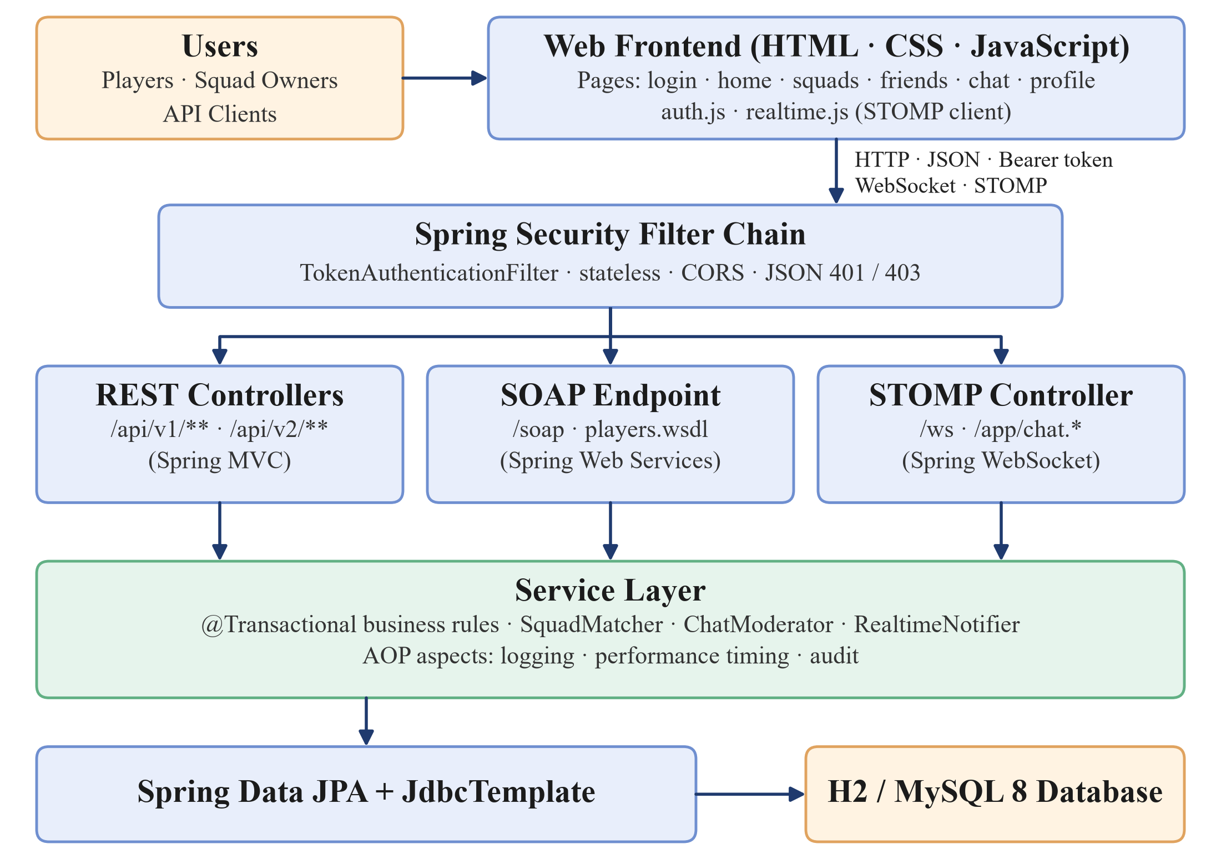
Figure 2.1: System Architecture

2.2 System Flow
- A new player registers with a username, an e-mail address and a password; the password is stored only as a BCrypt hash.
- The player logs in and the server returns a bearer token, which the browser keeps for the session.
- The player completes the profile with the favourite game, skill level, platforms, play style, language, region and bio.
- The home page lists the squads that the player has not joined, and the player can search and filter them by name, game, language and open slots.
- The recommendation engine scores the open squads for the player and returns the best matches with the reasons.
- The player joins a squad, during which the server locks the squad and checks that it is not full, or creates a new squad.
- The player sends a friend request by username; the recipient is notified instantly over WebSocket and accepts or rejects the request.
- The player opens the chat page; the browser connects to the STOMP endpoint with the token, subscribes to the rooms of the player and loads the message history.
- Each message is validated, moderated, stored and broadcast to all subscribers of the room, while typing events are broadcast without being stored.
- Service calls are logged by the AOP aspects, and logins and account changes are written to a separate audit log.
- The player can update the profile, change the password, log out, which revokes the token, or delete the account, which removes all related data in a single transaction.

2.3 User Roles
Role | Main Access | Responsibilities
Player | Web Application | Maintain the profile, search players, create and join squads, manage friends and chat.
Squad Owner | My Squads | A player who created a squad; deletes the squad, while other members only leave it.
API Client | REST and SOAP Services | Reads public player and squad data through the REST client or the SOAP service.
Administrator | H2 Console and Logs | Inspects the data and monitors the application through the log and audit files.

2.4 System Modules
- Authentication and Player Profile – registration, login, logout, tokens, profile, password change and account deletion.
- Squad Management – creating, searching, filtering, joining, leaving and deleting squads.
- Squad Recommendation Engine – score-based matching of squads to the profile of a player.
- Friends Management – friend requests, responses, friend list and real-time updates.
- Real-Time Chat – STOMP chat rooms for squads and friends, moderation and typing indicators.
- Platform Statistics – counts and most played games calculated with Spring JDBC.
- SOAP Player Service – read-only player lookup through a contract-first WSDL.
- Logging, Audit and Error Handling – AOP aspects, Logback files and a global exception handler.
CHAPTER 3

TECHNOLOGIES USED

3.1 Java
Java is used as the primary programming language for the backend implementation of the application. It provides a robust, object-oriented programming environment that supports the development of scalable and maintainable software systems. Java is responsible for implementing the application logic, matching squads to players, moderating chat messages, managing transactions and interacting with the database through the persistence layer. Its strong type checking, exception-handling mechanisms and extensive library support make it suitable for developing reliable backend applications. The project is built for Java 17 or newer.

3.2 Spring Boot
Spring Boot 3.5 is used as the main backend framework for developing the application and implementing RESTful web services. It simplifies the development of Java-based applications by providing automatic configuration, dependency management and an embedded server. Spring Boot handles HTTP requests, manages application components through dependency injection and bean scopes, and exposes the APIs that are accessed by the web pages. Configuration values such as the port, the token lifetime, the banned words and the database credentials are supplied through properties and environment variables so that no confidential value is stored in the source code.

3.3 HTML, CSS and JavaScript
The frontend of the application is developed using HTML, CSS and JavaScript and is served as static content by Spring Boot. It provides pages for sign-up, login, the home page, the profile, friends, squads, chat and events with a dark, neon gaming theme. JavaScript uses the fetch API to communicate with the REST services and the STOMP client library to receive real-time messages. Icons and fonts are loaded from Font Awesome and Google Fonts.

3.4 RESTful Web Services
RESTful web services are used to establish communication between the web pages and the Spring Boot backend. REST APIs allow the application to create, retrieve, update and delete players, squads, friendships and messages. HTTP methods such as GET, POST, PUT and DELETE are used according to the type of operation, and standard status codes such as 200, 201, 400, 401, 403, 404 and 409 describe the result. List operations such as the player directory and squad search are paginated and sortable, filters can be carried in matrix variables, and the API is versioned through the URI and through a request header.

3.5 Spring Data JPA
Spring Data JPA is used as the persistence layer for interacting with the database. It simplifies database operations by providing repository interfaces that reduce the boilerplate code required for CRUD operations. It maps Java objects to database tables using the Java Persistence API with Hibernate as the implementation. Pagination and sorting are supported through the Pageable interface, and the project demonstrates derived queries, a named query, JPQL and native queries, modifying queries, an entity graph, a pessimistic lock and a custom repository implementation that builds dynamic filters with the Criteria API.

3.6 H2 and MySQL
The application can run on two relational databases. H2, an embedded file database, is the default so that the project runs without any installation, and its web console is used to inspect the data. MySQL 8 is supported through a separate profile and is created automatically on first start, with the credentials supplied through environment variables. The tables are created and updated by Hibernate, and on an empty database a data seeder loads 20 demo players, 18 squads, friendships and chat history.

3.7 Spring Security
Spring Security is used to protect the application. Players log in with a username or an e-mail address and a password, and passwords are stored only as BCrypt hashes. After a successful login the server issues a random 256-bit opaque token, stores it with an expiry time of 24 hours and returns it to the browser, which sends it in the Authorization header of every request. A custom filter authenticates the token, expired tokens are removed by an hourly scheduled job, and unauthenticated or forbidden requests receive a uniform JSON error. Ownership checks ensure that a player can read and change only their own account data.

3.8 Spring AOP
Spring AOP (Aspect-Oriented Programming) is used to implement logging, timing and auditing as cross-cutting concerns without modifying the business logic. A logging aspect applies before, after-returning and after-throwing advice to every public method of the service layer. A performance aspect uses around advice with a custom annotation to measure the execution time of selected controller methods and to warn about slow calls. An audit aspect records logins, password changes and account deletions in a separate audit log.

3.9 Validation and Exception Handling
Validation and exception handling ensure that the application receives correct input and handles errors in a consistent manner. Jakarta Bean Validation annotations check incoming information such as usernames, e-mail addresses, passwords, squad details and profile fields before it is processed. A centralized exception handler converts every error into a uniform JSON response containing the status, a readable message, the request path, a request identifier and field-level details. This prevents invalid data from being stored and provides meaningful error messages to the user.

3.10 SOAP Web Service
A SOAP-based player service is included in the application to demonstrate communication using the SOAP protocol. The service is developed with Spring Web Services using the contract-first approach, in which the request and response messages are first defined in an XML schema (XSD). The service returns public player information through structured XML messages, reports problems as SOAP faults, and its WSDL is generated and published automatically by the application.

3.11 WebSocket and STOMP
Spring WebSocket with the STOMP messaging protocol replaces Socket.io of the original application and provides the real-time features. A simple in-memory message broker delivers messages to the subscribers of a chat room and sends private notifications to a single player. An interceptor authenticates the bearer token when a client connects and checks the access rights of a player before a subscription to a room is accepted.

3.12 Maven and VS Code
Apache Maven, through the Maven wrapper, is used to download the dependencies, build the project, run the application and execute the tests. JUnit 5, Spring Test and MockMvc are used for automated testing, and Postman is used to try the REST and SOAP services. Visual Studio Code (VS Code) is the primary development environment, and its integrated terminal is used to run the Maven commands.
CHAPTER 4

DATABASE DESIGN

4.1 Database Tables Overview
The project database is designed around the main entities required for squad building. The principal tables are USERS, SQUADS, FRIENDSHIPS, MESSAGES and AUTH_TOKENS, together with the tables SQUAD_MEMBERS, USER_GAME_TAGS and USER_PLATFORMS that store the members of a squad and the ordered lists of a player. Primary keys uniquely identify records, while foreign keys connect related records. The tables are generated from the JPA entities, and the main tables and their relationships are shown in Figure 4.1.
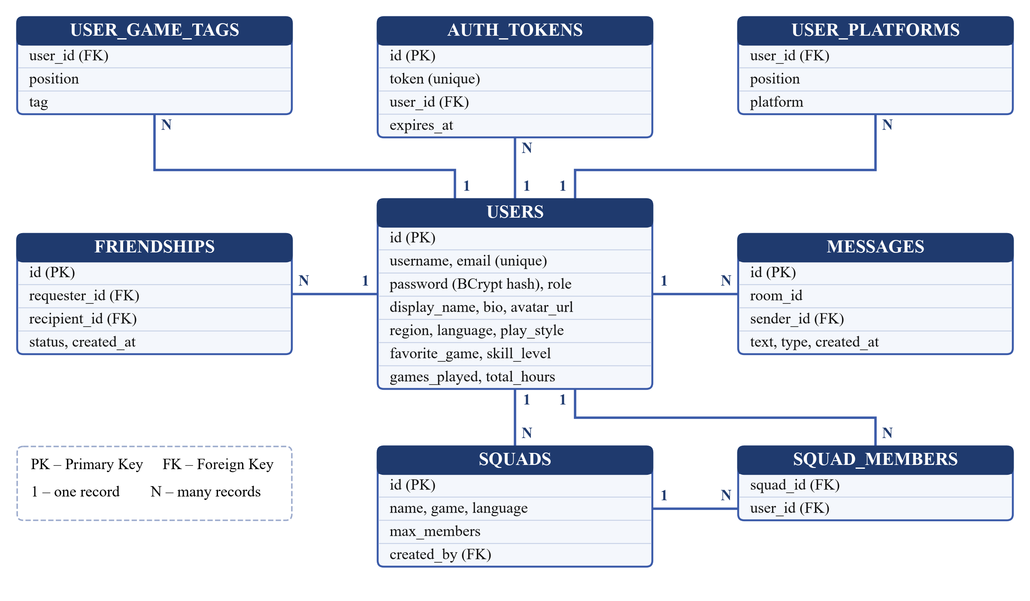
Figure 4.1: Database Design

4.2 Users Table
The USERS table stores the information required to identify, authenticate and describe a player.
- id – Primary Key
- username (unique, up to 30 characters)
- email (unique)
- password (BCrypt hash)
- role (USER, ADMIN)
- display_name, bio, region, language and avatar_url
- first_name, last_name, age, gender and location
- favorite_game, skill_level, play_style, games_played and total_hours
- created_at and updated_at

4.3 User Game Tags and Platforms Tables
The USER_GAME_TAGS and USER_PLATFORMS tables store the ordered lists of games and gaming platforms of a player.
- USER_GAME_TAGS: user_id – Foreign Key (USERS), position, tag
- USER_PLATFORMS: user_id – Foreign Key (USERS), position, platform

4.4 Squads Table
The SQUADS table stores the “Looking for Group” lobbies created by the players.
- id – Primary Key
- name and game
- language (default English)
- max_members (between 2 and 20, default 5)
- created_by – Foreign Key (USERS)
- created_at

4.5 Squad Members Table
The SQUAD_MEMBERS table is the join table of the many-to-many relationship between squads and players. The creator of a squad is added as its first member.
- squad_id – Foreign Key (SQUADS)
- user_id – Foreign Key (USERS)

4.6 Friendships Table
The FRIENDSHIPS table stores a friend request and, after it is accepted, the friendship itself.
- id – Primary Key
- requester_id – Foreign Key (USERS)
- recipient_id – Foreign Key (USERS)
- status (PENDING, ACCEPTED, REJECTED)
- created_at and updated_at
- unique constraint on (requester_id, recipient_id)

4.7 Messages Table
The MESSAGES table stores the chat messages of squad rooms and private rooms. It has an index on the room and the creation time so that the history of a room is read quickly.
- id – Primary Key
- room_id (squad_{id} or dm_{idA}_{idB})
- sender_id – Foreign Key (USERS)
- text (up to 2000 characters)
- type (DM, GROUP)
- created_at

4.8 Auth Tokens Table
The AUTH_TOKENS table stores the bearer tokens issued at login.
- id – Primary Key
- token (unique, 64 hexadecimal characters)
- user_id – Foreign Key (USERS)
- expires_at

4.9 Database Relationships
The database relationships connect players to their game tags, platforms, tokens, friendships and messages, and connect squads to their owner and, through SQUAD_MEMBERS, to all of their members. A chat room is identified by a text key built from the squad or from the two friends, which keeps the MESSAGES table independent of the type of room. When a player deletes an account, the application removes the memberships, friendships, messages and tokens of the player in a single transaction and passes the ownership of the squads of the player to another member.
CHAPTER 5

SYSTEM MODULES

5.1 Authentication and Player Profile
The Authentication and Player Profile module allows a player to register, log in, log out and manage the account. Registration validates the username (3 to 30 letters, digits, dots, underscores or hyphens), the e-mail address and the password (6 to 72 characters), and rejects duplicate usernames and e-mail addresses. A player can log in with the username or the e-mail address; a wrong password returns 401, and the server returns a bearer token with the profile of the player. The token is valid for 24 hours and is revoked at logout.
The profile contains personal information, gaming information (favourite game, skill level, platforms, play style, games played and total hours), game tags, language, region and a bio. A player can change only their own profile, change the password after confirming the current one, or delete the account.

5.2 Squad Management
The Squad Management module is responsible for the squads. A player creates a squad with a name, a game, a language and a maximum size between 2 and 20, and becomes its first member. Squads can be searched by text, game, language and open slots, with pagination and sorting, and they can also be filtered with matrix variables or listed by popularity. Joining a squad locks the squad row so that two players cannot fill the same last slot; joining a full squad or a squad of which the player is already a member returns 409. The owner deletes the whole squad together with its chat history, while any other member simply leaves it.

5.3 Squad Recommendation Engine
The Squad Recommendation Engine suggests squads that suit a player. For every open squad that the player has not joined, a set of scorers adds points and a reason, and the squads with a positive total are returned in descending order of the score. The scorers are listed below.
- GameAffinityScorer – 50 points when the squad plays the favourite game of the player and 30 points when it plays one of the game tags of the player.
- LanguageScorer – 25 points when the language of the squad is the language of the player.
- OpenSlotsScorer – 2 points for every open slot, up to 5 slots, so that a player is not squeezed into the last slot.
For example, a Valorant squad that speaks English and has four open slots scores 50 + 25 + 8 = 83 for a player whose favourite game is Valorant. The matcher is a prototype-scoped bean that receives every scorer by collection autowiring, so a new rule can be added without changing the existing code.

5.4 Friends Management
The Friends Management module lets a player send a friend request by username, with an optional leading @. A player cannot add themselves, and a request to an existing friend or an earlier request returns 409. Only the recipient can accept or reject a request, either of the two friends can remove the friendship, and the friend list is sorted by display name. Every change publishes an event that is delivered after the transaction commits to the private queue of both players, so the pages update immediately without a refresh.

5.5 Real-Time Chat
The Real-Time Chat module provides rooms for every squad (squad_{id}) and for every pair of friends (dm_{idA}_{idB}). Only the members of a squad and the two friends can read or write in a room. A client connects to the /ws endpoint with its bearer token, subscribes to the topic of a room and sends messages to the application destination. Before a message is stored, the moderator trims it, rejects empty messages and messages longer than 2000 characters, and replaces banned words with asterisks. The module also broadcasts typing indicators, and the history of a room can be read through the REST API.

5.6 Platform Statistics
The Platform Statistics module returns the number of players, squads, open squads and messages and the most played games together with their squad and player counts. The data is calculated by a Spring JDBC data access object that uses JdbcTemplate and a RowMapper with plain SQL, and the response is cacheable for 30 seconds.

5.7 SOAP Player Service
The SOAP Player Service allows external systems to read public player information. The getPlayer operation returns the profile of a player by username, and the searchPlayers operation returns up to 50 matching players with the total number of matches. The e-mail address of a player is never exposed through this service, and an unknown player or an invalid search produces a SOAP fault.

5.8 Logging, Audit and Error Handling
This module records what the application does and reports problems in a uniform way. Logback writes the application log to the console and to a rolling file, and a separate audit log keeps the security-relevant events. A request-scoped bean generates a short identifier for every request, which is returned in the X-Request-Id header and in every error response, so a problem reported by a user can be traced in the log.
CHAPTER 6

API AND IMPLEMENTATION

6.1 Frontend Implementation
The frontend is developed using HTML, CSS and JavaScript and is placed in the static resources of the Spring Boot application, so one server provides both the pages and the API. A single authentication script stores the token and the player in the session storage of the browser and attaches the token to every request, and the pages redirect to the login screen when nobody is logged in. A real-time script wraps the STOMP client behind simple on and emit calls and reconnects automatically. The root address redirects to the home page through a classic Spring MVC controller.

6.2 Backend Implementation
The backend is developed using Java Spring Boot and is organized into controller, service, repository, entity, DTO, security, aspect, matching, SOAP, WebSocket and configuration packages, as shown in Figure 6.1. Controllers receive requests and return responses, services contain the business rules, and repositories perform database operations through Spring Data JPA. Data transfer objects are Java records with validation annotations, so that internal entities are never exposed directly. Beans are wired by constructor injection, while the chat moderator is created in a Java configuration class and receives its settings through setter injection.
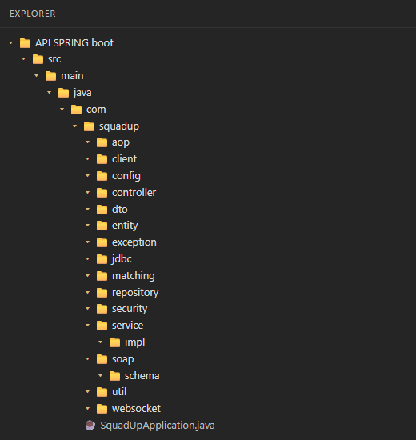
Figure 6.1: Project Structure

6.3 REST API Operations
The project uses RESTful web services to support the major operations of the system. All endpoints except registration and login require a bearer token. The API layer receives requests, processes them through the service layer and returns JSON responses to the frontend. The important operations are listed below.
Method | Endpoint | Purpose
POST | /api/v1/auth/register | Register a new player
POST | /api/v1/auth/login | Log in and receive a token
POST | /api/v1/auth/logout | Revoke the current token
GET | /api/v1/users?page=0&size=10 | Paginated player directory
GET | /api/v1/users/search?username=nin | Search players by username
GET | /api/v1/users/players?game=Valorant | Players of a game, sorted
GET | /api/v1/users/{id} | View a player profile
PUT | /api/v1/users/{id} | Update the own profile
PUT | /api/v1/users/{id}/password | Change the own password
DELETE | /api/v1/users/{id} | Delete the own account
GET | /api/v1/friends/{userId} | List the accepted friends
GET | /api/v1/friends/pending/{userId} | List incoming friend requests
POST | /api/v1/friends/request | Send a friend request
POST | /api/v1/friends/respond | Accept or reject a request
DELETE | /api/v1/friends/{friendshipId} | Remove a friend
GET | /api/v1/squads?game=Valorant&openOnly=true | Search squads with filters
GET | /api/v1/squads/browse/filter;game=Valorant | Filter squads with matrix variables
GET | /api/v1/squads/popular | Squads ordered by member count
GET | /api/v1/squads/recommended?limit=5 | Recommended squads with reasons
GET | /api/v1/squads/{id} | View one squad
GET | /api/v1/squads/user/{userId} | Squads joined by the player
GET | /api/v1/squads/public/{userId} | Squads the player can join
POST | /api/v1/squads | Create a squad (201 and Location)
POST | /api/v1/squads/{id}/join | Join a squad
DELETE | /api/v1/squads/{id} | Delete the squad or leave it
GET | /api/v2/squads | Compact squad representation (v2)
GET | /api/v1/chat/history/{roomId}?limit=50 | Chat history of a room
GET | /api/v1/stats?topGames=5 | Platform statistics

6.4 Transaction Management
Transaction management is used to maintain consistency during important operations. Service classes are read-only transactional by default, and every method that changes data opens a read-write transaction. Joining a squad reads the squad with a pessimistic write lock (SELECT ... FOR UPDATE), so two simultaneous requests cannot overfill it. Deleting an account removes the memberships, friendships, messages and tokens of the player and re-assigns the squads in one transaction that either fully succeeds or fully fails. Real-time friend notifications are sent only after the transaction has committed, and a profile update flushes inside its transaction so that a duplicate username is reported as 409.

6.5 Spring AOP Logging
Spring AOP is used to demonstrate logging as a cross-cutting concern. The logging aspect applies @Before, @AfterReturning and @AfterThrowing advice to all public service methods and writes the method, its arguments, its result and rejected calls; it does not log the passwords, because the request objects mask them. The performance aspect uses @Around advice on methods annotated with @TrackExecutionTime and logs the duration in milliseconds, with a warning when the call is slower than the configured threshold of 500 ms. The audit aspect writes logins, failed logins, password changes and account deletions to the separate audit log.

6.6 Validation and Exception Handling
Validation ensures that incoming player, squad, friend and profile information satisfies the defined rules. A global exception handler provides a consistent mechanism for reporting errors as JSON: validation failures and malformed requests return status 400 with field-level messages, unauthenticated requests return 401, access to the data of another player returns 403, missing records return 404, and business-rule violations such as a full squad or a duplicate username return 409. Unexpected errors return 500 with a generic message, and internal details such as stack traces are never included in a response.

6.7 Real-Time Communication with WebSocket
Real-time communication is implemented with Spring WebSocket and the STOMP protocol. The application destinations start with /app, the broker delivers messages from /topic and /queue, and private messages use the /user prefix. A channel interceptor authenticates the CONNECT frame with the bearer token, accepts a SUBSCRIBE to a room only for its members and rejects a SEND from an unauthenticated client. The destinations are listed below.
Destination | Direction | Purpose
/ws | Handshake | WebSocket endpoint; the CONNECT frame must carry the bearer token
/app/chat.send | Client to server | Send a message {roomId, text}; it is moderated, stored and broadcast
/app/chat.typing | Client to server | Typing indicator {roomId, typing}
/topic/room.{roomId} | Server to clients | Messages and typing events of a room (members only)
/user/queue/friends | Server to one player | A friend-update event when requests or friendships change
/user/queue/errors | Server to sender | An error message when sending fails

6.8 SOAP Player Service
In addition to RESTful APIs, the project includes a SOAP-based player service. The contract is defined first in the players.xsd schema with the namespace http://squadup.com/soap/players, and Spring Web Services generates the WSDL, which is available at the address /soap/players.wsdl. An endpoint class maps the getPlayerRequest and searchPlayersRequest messages to its methods, and the unknown-player and invalid-search cases are mapped to client SOAP faults. This service demonstrates web-service integration for standardized lookups and complements the REST-based operations.

6.9 API Versioning, CORS and REST Client
The API is versioned in the URI as /api/v1. A second, compact representation of a squad, with the member count, the open slots and a full flag, is available as /api/v2/squads and also through the X-API-Version: 2 header on /api/squads. Cross-origin requests to /api/** are enabled by global CORS rules, and the statistics controller additionally uses @CrossOrigin. The SquadUpApiClient class is a REST client built with RestTemplate that logs in, keeps the token and adds it to every following request; it is used by the tests to call the running application.

6.10 Testing
The application is verified with 55 automated JUnit 5 tests that run on an in-memory H2 database without demo data. They cover dependency injection and bean scopes, AOP advice, repositories, the REST controllers with MockMvc, security, validation, the SOAP endpoint, the WebSocket chat and the REST client. The tests are listed in the table below, and the result of the test run is shown in Chapter 7.
Test Class | Tests | Coverage
AutowiringAndLoggingTest | 8 | Component scanning, autowiring, Java configuration, setter injection, bean scopes and Logback output
AopAdviceTest | 4 | Before, after-returning and after-throwing advice and the audit trail
RepositoryTest | 8 | CRUD, named, derived, JPQL, native and Criteria API queries, pagination and sorting
AuthAndUserApiTest | 16 | Registration, login, tokens, profile, ownership checks, password, account deletion and CORS
SquadFriendChatApiTest | 8 | Squads, search, matrix variables, versioning, recommendations, friends, chat history and statistics
ChatModeratorTest | 3 | Masking of banned words and rejection of empty or long messages
PlayerSoapEndpointTest | 4 | WSDL publication, getPlayer, searchPlayers and SOAP faults
ChatWebSocketTest | 2 | Broadcast to room subscribers and rejection of invalid tokens
SquadUpApiClientTest | 2 | REST client operations and error handling
Total | 55 | All tests pass (Failures: 0, Errors: 0, Skipped: 0)

CHAPTER 7

OUTPUT SCREENS

7.1 Login Screen
The Login screen allows a registered player to sign in with a username or an e-mail address and a password. It also provides a link for creating a new account.
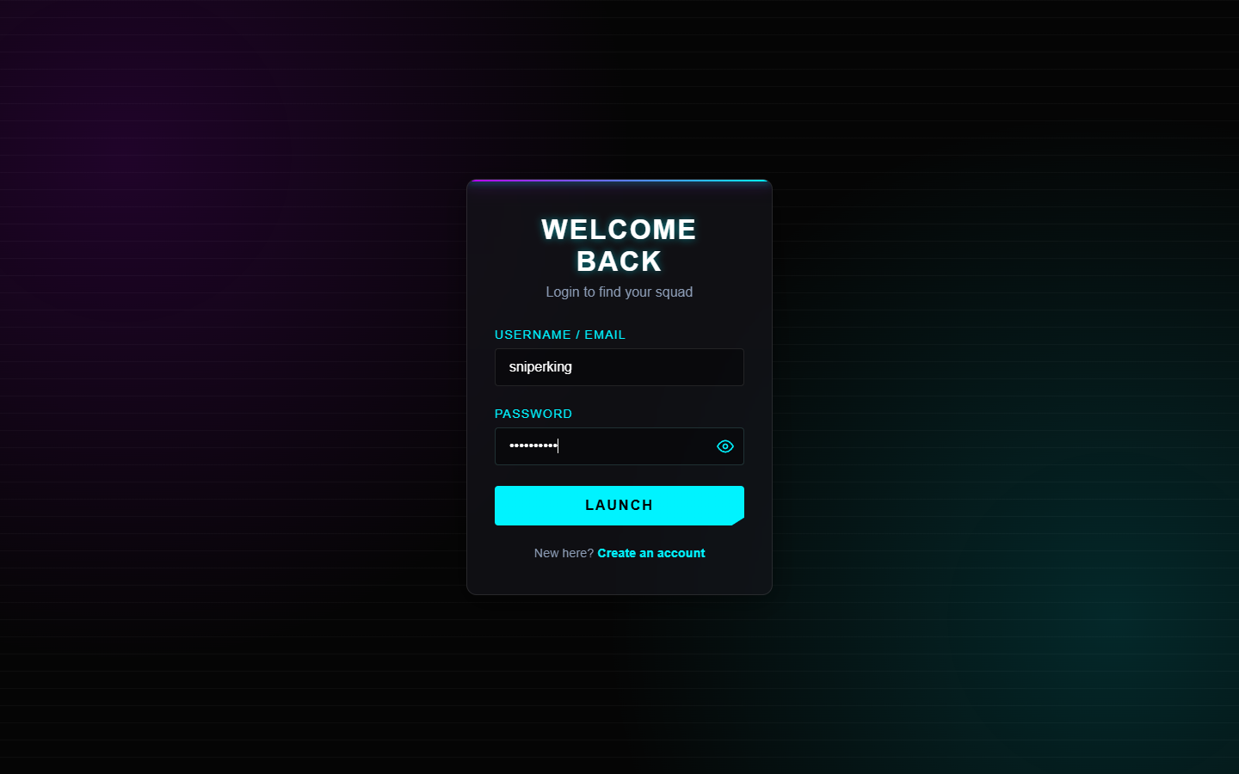
Figure 7.1: Login Screen

7.2 Player Profile
The My Profile screen presents the personal information, account information, gaming information and bio of the player, together with the number of friends and squads. The player can edit the profile, log out or delete the account from this screen.
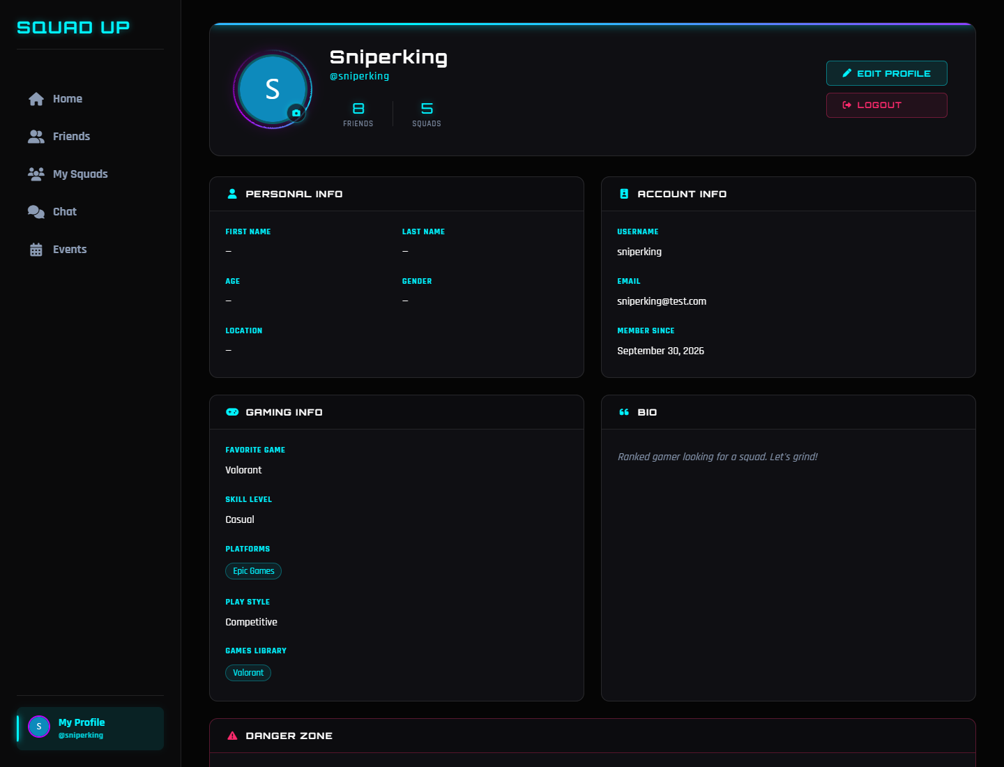
Figure 7.2: Player Profile

7.3 Filtered Squad Lobby
The Home screen lists the squads that the player can join. The filter window narrows the list by name, game and language, and shows the members, the language and a button for joining each squad.
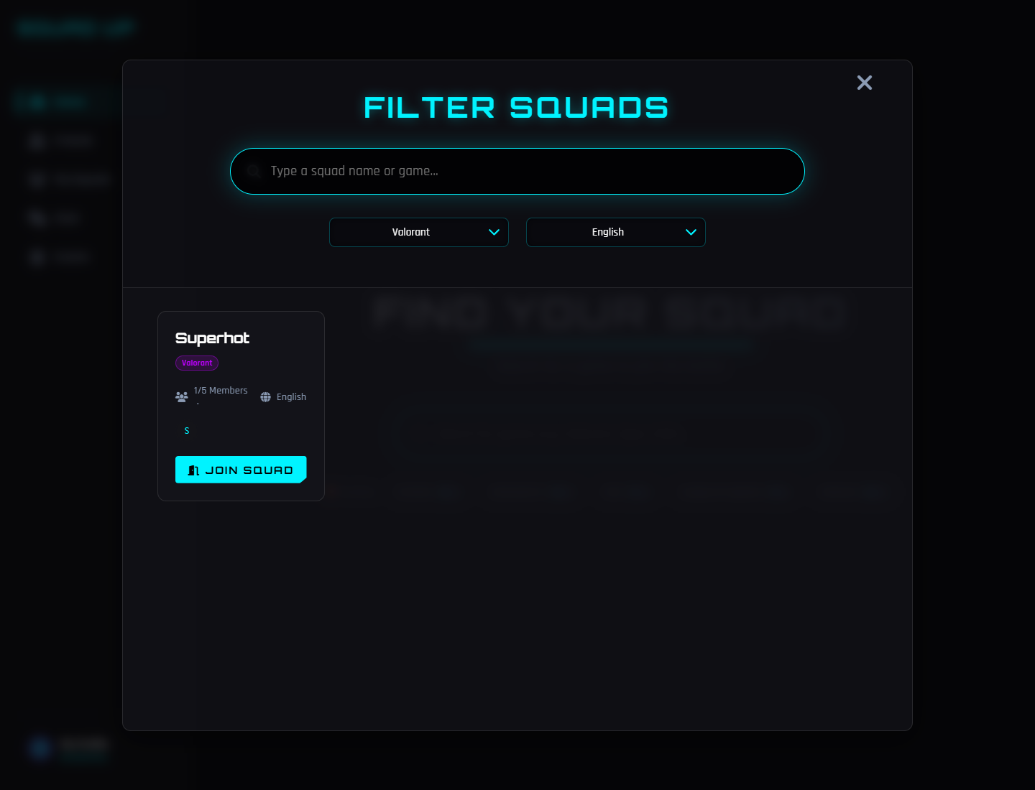
Figure 7.3: Filtered Squad Lobby

7.4 Recommended Squads
The recommendation service returns the squads that best match the profile of the player. Each result contains the squad, the score and the reasons, such as plays the favourite game, speaks the language of the player and the number of open slots.
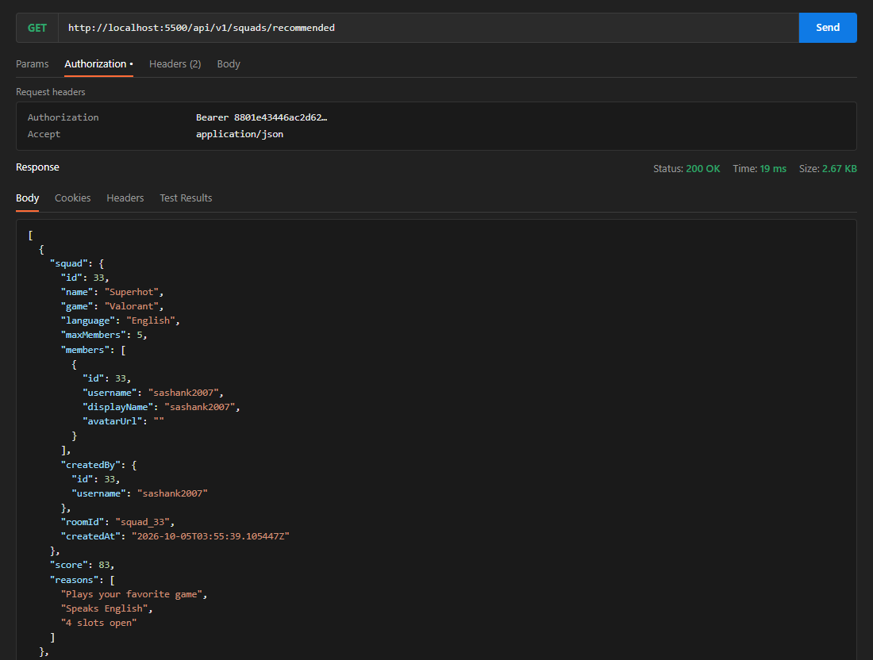
Figure 7.4: Recommended Squads with Score and Reasons

7.5 Friends List
The Friends screen shows the accepted friends of the player with buttons for chatting and removing a friend, and a field for sending a friend request by username.
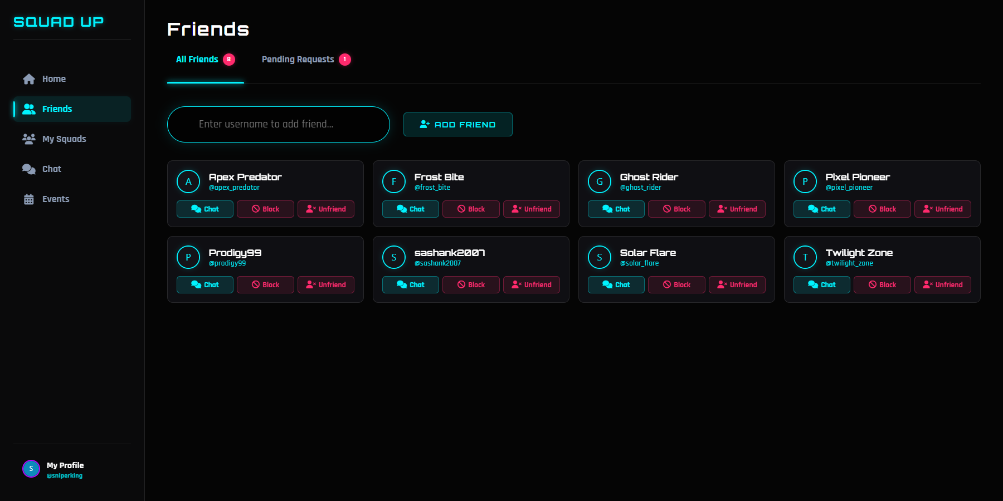
Figure 7.5: Friends List

7.6 Pending Friend Requests
The Pending Requests tab lists the incoming friend requests, which the player can accept or reject.
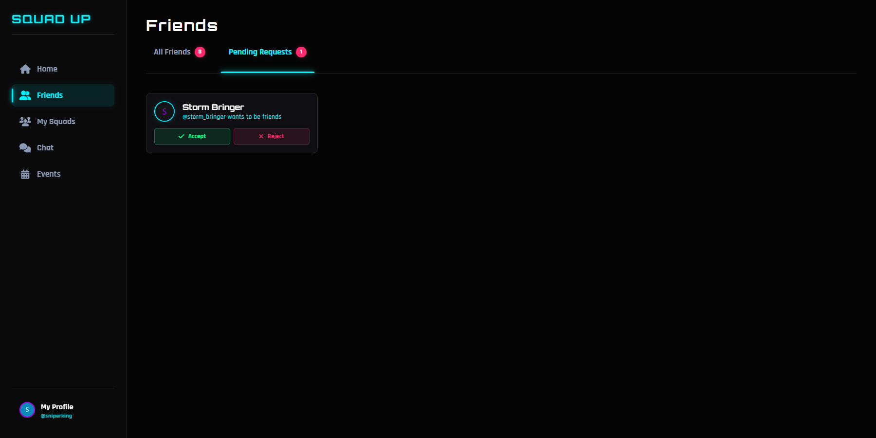
Figure 7.6: Pending Friend Requests

7.7 Real-Time Friend Notifications
When a friend request is sent, the screen of the recipient is updated instantly through the WebSocket queue, and the request counter changes without a page refresh. When the request is accepted, the screen of the sender is updated in the same way.
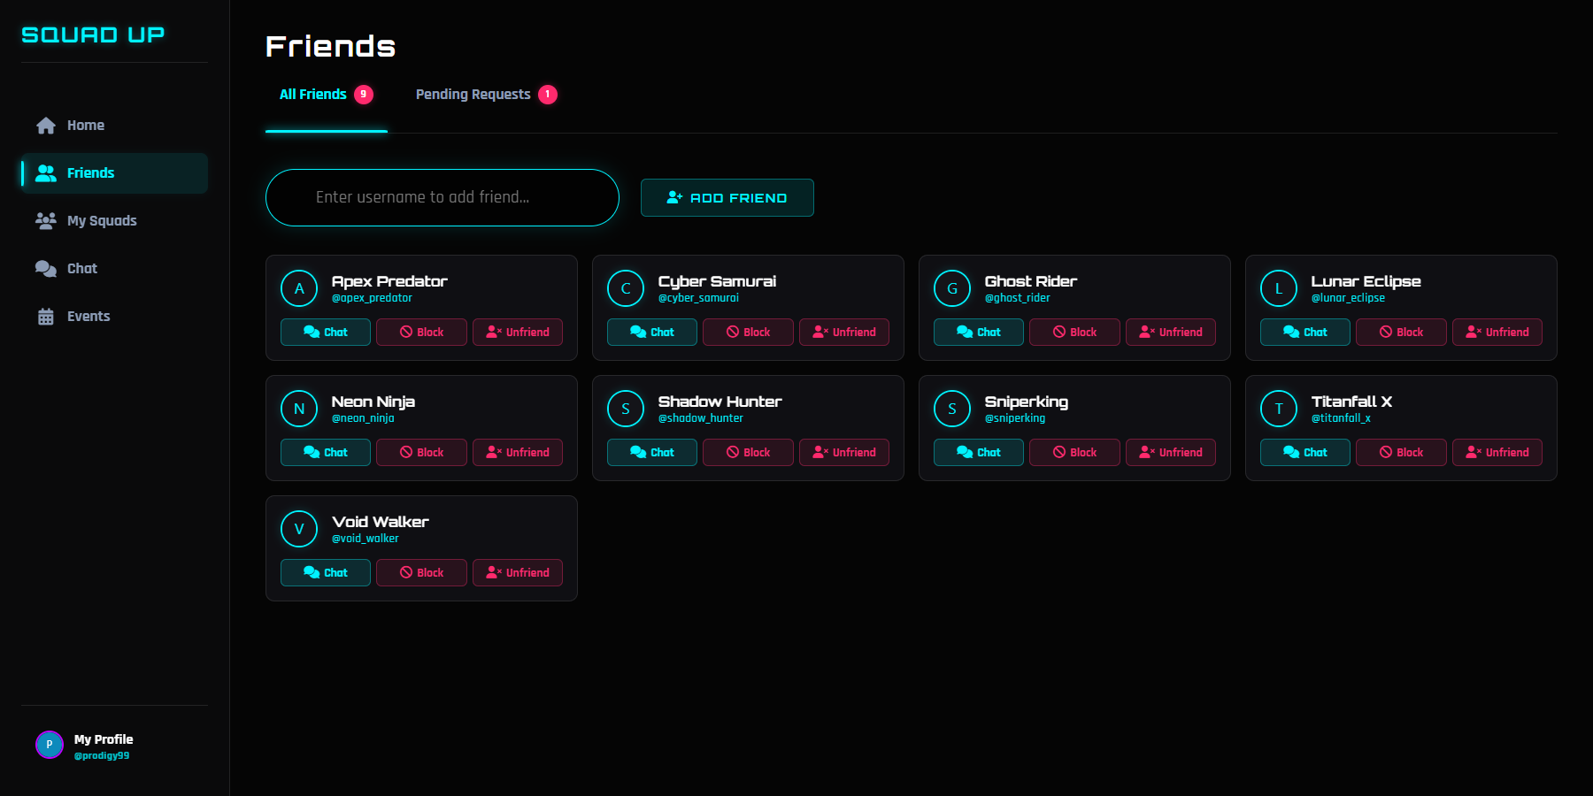
Figure 7.7: Request Received in Real Time
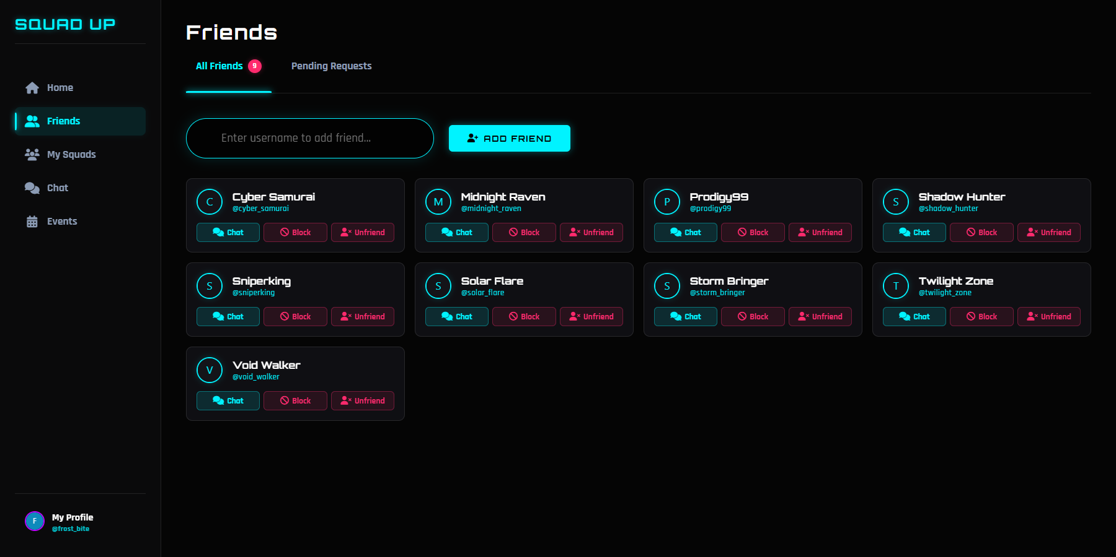
Figure 7.8: Request Accepted in Real Time

7.8 Squad Chat and Message Moderation
The Chat screen lists the squads and friends of the player and shows the conversation of the selected room. A banned word in a message is replaced by asterisks before the message is stored and shown to the other members.
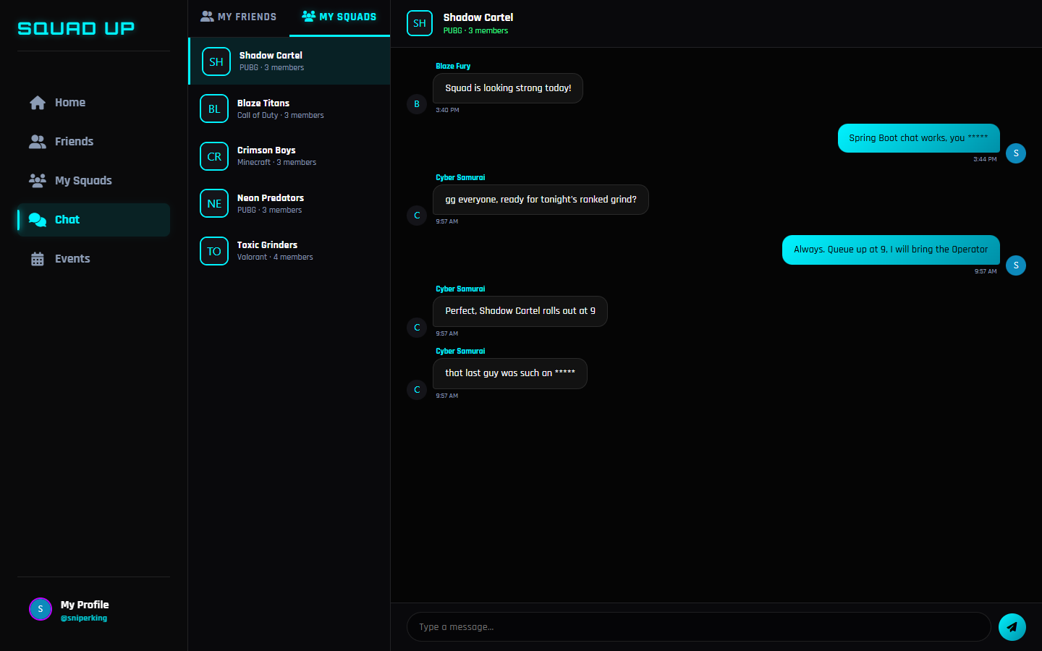
Figure 7.9: Squad Chat with a Censored Message

7.9 Typing Indicator
While a squad mate is typing, a typing indicator is shown in the header of the room.
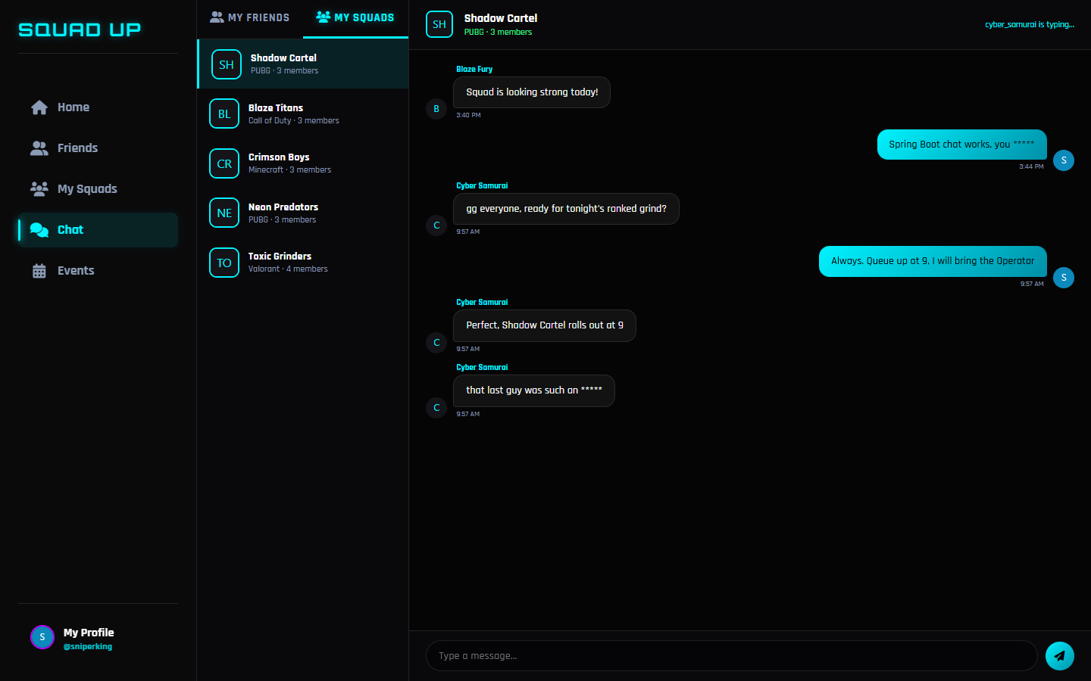
Figure 7.10: Typing Indicator

7.10 Paged Player Search
The player directory is returned page by page and sorted by username. The response contains the content of the page and the paging information.
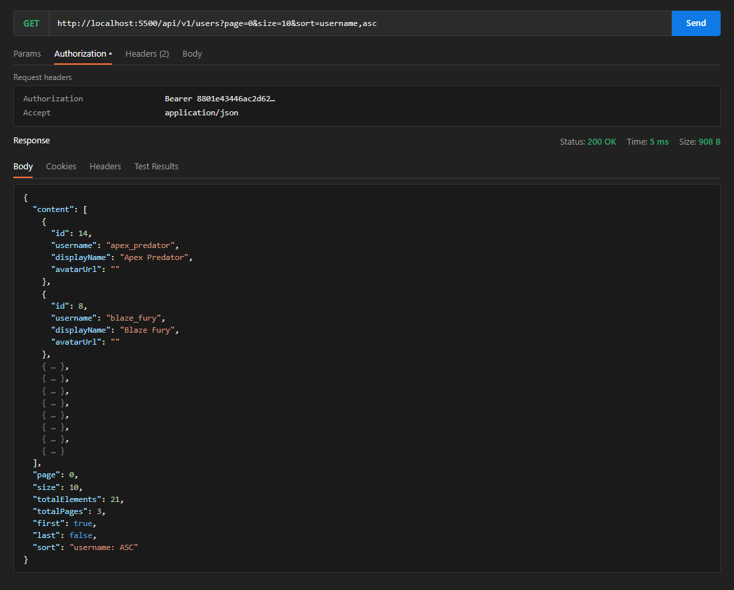
Figure 7.11: Paged Player Directory

7.11 Filtering with Matrix Variables
The filter for squads can also be carried in a path segment as matrix variables, for example game=Valorant;language=English.
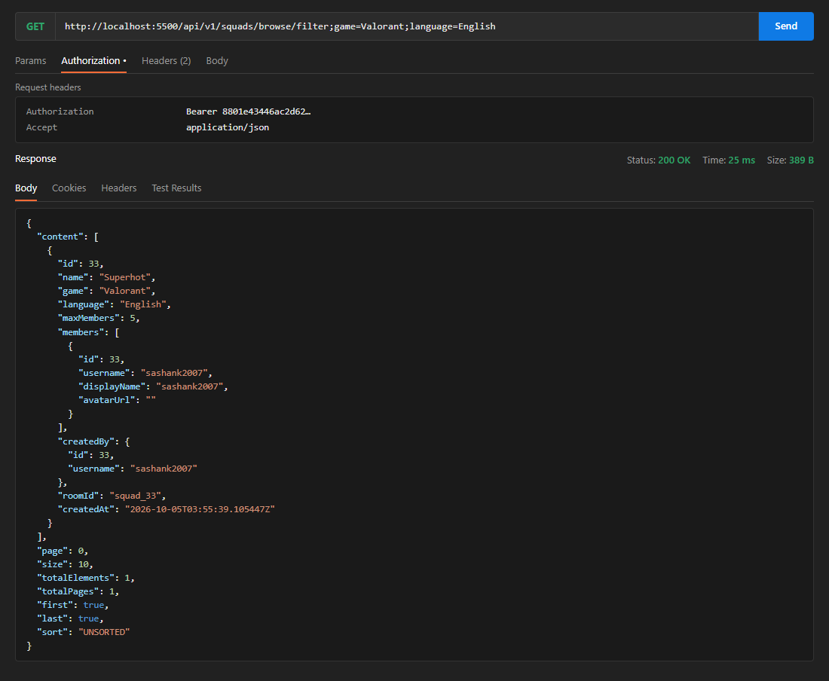
Figure 7.12: Matrix Variable Request and Response

7.12 Login API and Token Response
The login service accepts the credentials as JSON and returns the bearer token together with the profile of the player. The token is then sent in the Authorization header of every request.
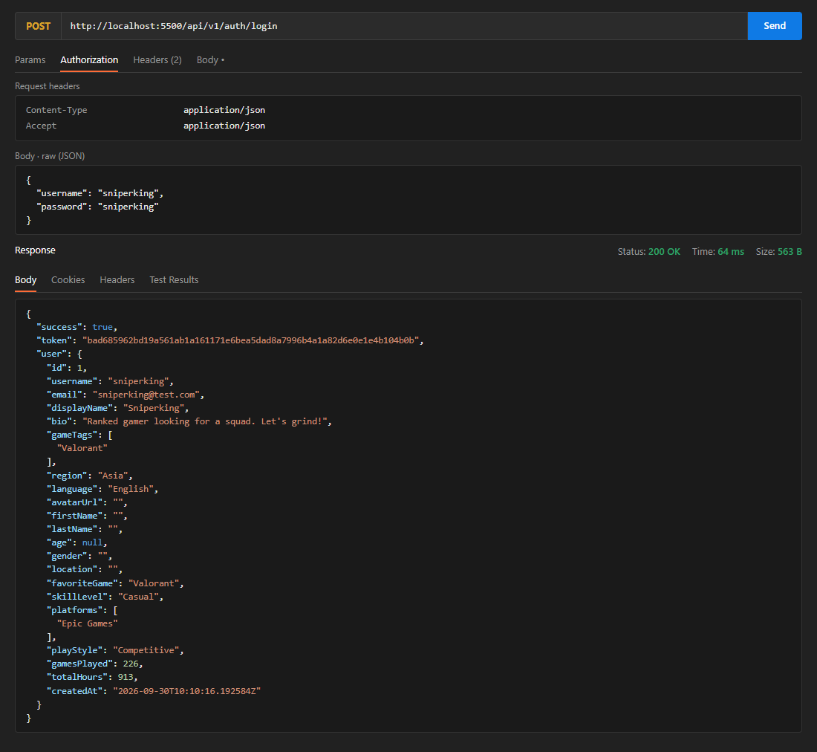
Figure 7.13: Login Response with Bearer Token

7.13 Secured API Error Responses
A request without a token receives a uniform JSON error with status 401, and an attempt to change the data of another player receives status 403.
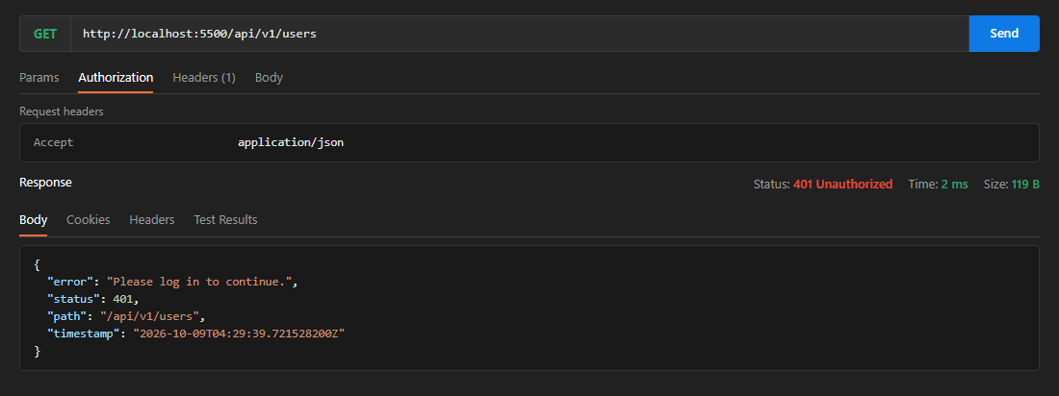
Figure 7.14: 401 Unauthorized Response
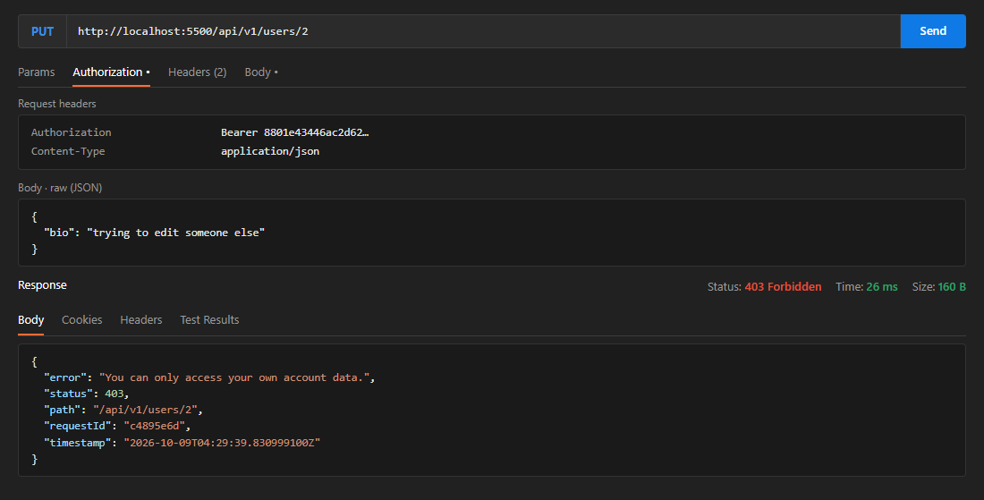
Figure 7.15: 403 Forbidden Response

7.14 SOAP Player Service
The WSDL of the SOAP service is generated by the application and can be opened in a browser or imported into a SOAP client. A getPlayerRequest returns the public profile of a player as an XML message.
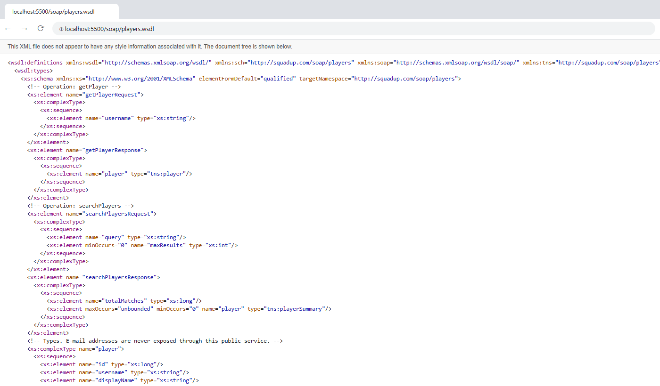
Figure 7.16: WSDL of the SOAP Service
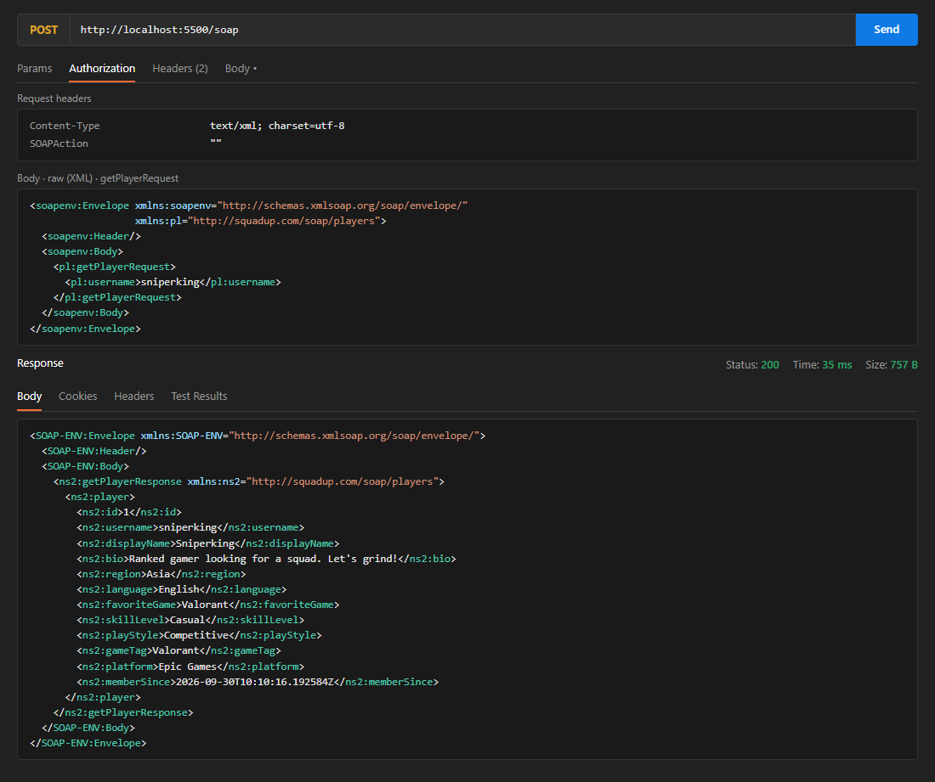
Figure 7.17: SOAP Request and Response

7.15 Platform Statistics
The statistics service returns the number of players, squads, open squads and messages and the most played games.
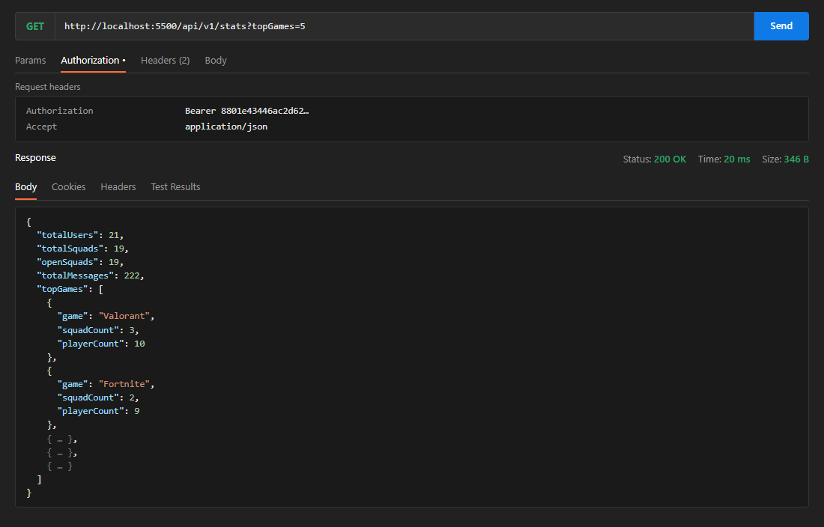
Figure 7.18: Platform Statistics

7.16 Audit and Performance Logs
The audit log records the logins of the players, and the application log records the time taken by the annotated controller methods.
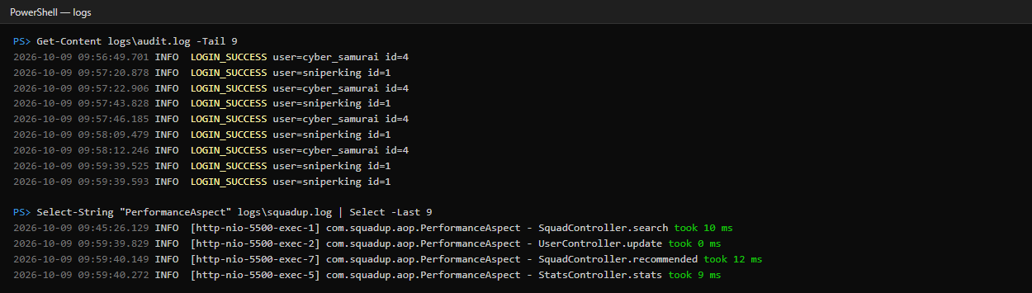
Figure 7.19: Audit and Performance Logs

7.17 Seeded Database
On the first start, the database is filled with demo players, squads, friendships and chat messages. The H2 console shows the tables and the stored players.
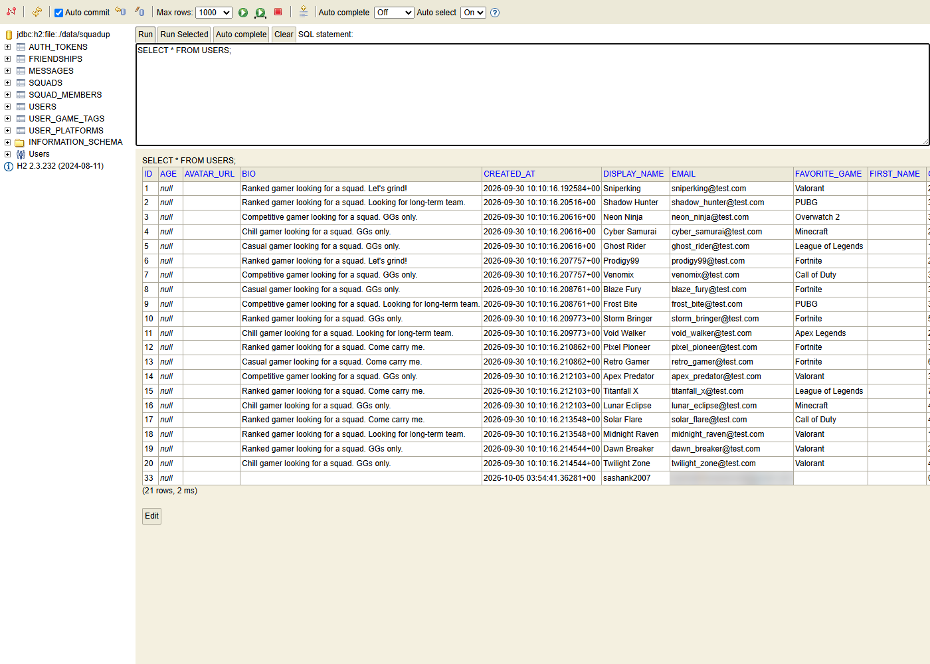
Figure 7.20: Seeded Players in the H2 Console

7.18 Automated Test Result
The Maven test run executes all 55 tests; all of them pass and the build is successful.
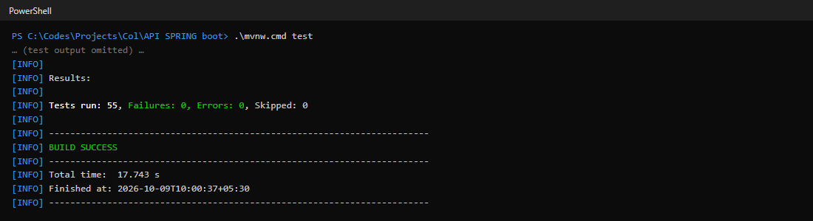
Figure 7.21: Maven Test Result
CHAPTER 8

CONCLUSION

8.1 Summary
SquadUp provides a centralized, structured and reliable platform for finding teammates in multiplayer games. The system brings together players, squads, friendships and chat conversations within a single application. By recommending squads that play the favourite game of a player and speak the language of the player, it reduces the social gaps that standard matchmaking leaves open.
The application follows a full-stack architecture consisting of a browser frontend and a Java Spring Boot backend. The frontend provides interactive pages for players, while the backend handles business logic, validation, security, database operations and service communication. RESTful APIs, WebSocket messaging and a SOAP service provide the communication between the clients and the backend.
Spring Data JPA is used as the persistence layer for interacting with the H2 or MySQL database. The system applies validation and business rules to maintain the consistency and integrity of the data. Passwords are stored as BCrypt hashes, every request is authenticated with a bearer token, players can access only their own data, and joining a squad is protected by a pessimistic lock.
The implemented modules include Authentication and Player Profile, Squad Management, the Squad Recommendation Engine, Friends Management, Real-Time Chat, Platform Statistics, the SOAP Player Service, and Logging, Audit and Error Handling. Players can maintain a profile, find and join squads, receive explained recommendations, add friends and chat with their squad mates in real time.
The project also demonstrates several important concepts related to backend and web-service development. These include dependency injection and bean scopes, RESTful web services, pagination, matrix variables, API versioning, CORS, transaction management, Spring Data JPA, Spring Security, Spring AOP-based logging, input validation, centralized exception handling, SOAP-based and WebSocket-based integration. The reliability of the implementation is supported by 55 automated tests.
Overall, SquadUp provides a practical implementation of a modern player matching platform. It improves the quality of the teams that players form, provides moderated real-time communication and establishes a foundation that can be extended with additional services in the future.

8.2 Future Enhancements
The current system provides the core functionality required for player matching; however, several additional features can be incorporated in future versions to make the system more comprehensive, scalable and convenient.

8.2.1 Skill-Based and Latency-Aware Matching
The recommendation engine is built from independent scorer beans. New scorers that use the rank, the region and the measured latency of a player can be added without changing the existing code, so that the skill of the teammates is considered together with their language and play style.

8.2.2 Voice Chat and Media Sharing
The text chat can be extended with voice rooms, image sharing and game invitations so that squads can coordinate completely within the platform.

8.2.3 Event and Tournament Management
The Events page of the interface can be connected to the backend so that players can register their squads for tournaments, and organizers can manage brackets, schedules and results.

8.2.4 Enhanced Notifications
The notification system can be extended with e-mail and push notifications, squad invitations and join requests, so that players are informed immediately even when they are not on the website.

8.2.5 Scalable Service Architecture
For a large number of players, the application can be divided into independently deployable services such as player management, squad management, chat and notifications, and the in-memory message broker can be replaced by an external broker. This approach can improve scalability and independent deployment of application components.

8.2.6 Mobile Application Support
A dedicated mobile application can be developed on top of the existing REST and WebSocket APIs to give players convenient access to squads, friends and chat from their smartphones.

8.2.7 Improved Security and Moderation
Future versions can introduce token refresh, multi-factor authentication, request rate limiting and an administrator console. The Block button of the friends screen can be connected to a backend service, together with player reports and stronger moderation of toxic behaviour.

8.2.8 Cloud Deployment and Monitoring
The application can be deployed on cloud infrastructure with a managed MySQL database to support scalability and availability. Monitoring, automated backups and performance analysis can be incorporated to improve reliability and operational management.

REFERENCES
[1] Oracle. Java Documentation. https://docs.oracle.com/en/java/
[2] Spring. Spring Boot Documentation. https://docs.spring.io/spring-boot/
[3] Spring. Spring Framework Documentation. https://docs.spring.io/spring-framework/
[4] Spring. Spring Data JPA Documentation. https://docs.spring.io/spring-data/jpa/
[5] Spring. Spring Security Documentation. https://docs.spring.io/spring-security/
[6] Spring. Spring Web Services Documentation. https://docs.spring.io/spring-ws/
[7] Spring. WebSocket and STOMP Messaging. https://docs.spring.io/spring-framework/reference/web/websocket.html
[8] Hibernate. Hibernate ORM Documentation. https://hibernate.org/orm/documentation/
[9] MySQL. MySQL Reference Manual. https://dev.mysql.com/doc/
[10] H2 Database Engine. H2 Documentation. https://www.h2database.com/html/main.html
[11] JUnit Team. JUnit 5 User Guide. https://junit.org/junit5/docs/current/user-guide/
[12] Apache Maven. Maven Documentation. https://maven.apache.org/guides/
[13] MDN Web Docs. HTML, CSS and JavaScript Documentation. https://developer.mozilla.org/
[14] STOMP. STOMP Protocol Specification. https://stomp.github.io/

